**AWS Task-4**

**Launch an EC2 instance (Linux and Windows) along with a web server. Then, create an EBS volume of 5 GB, attach it to an EC2 machine (Linux and Windows), and take a snapshot. Finally, create an EBS volume using the taken snapshot.**

* **Launch an EC2 instance in Linux along with a web server.**

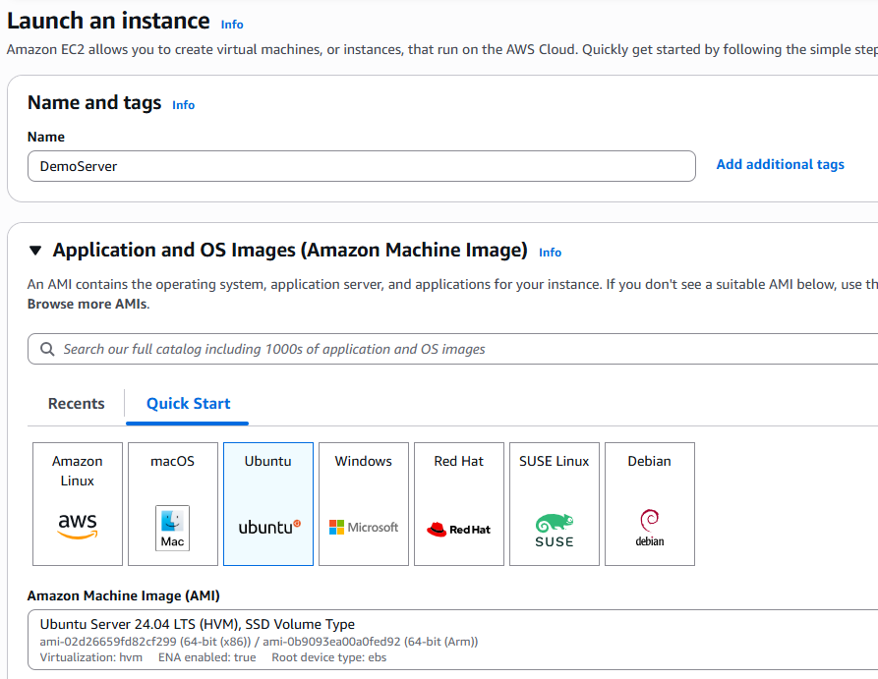

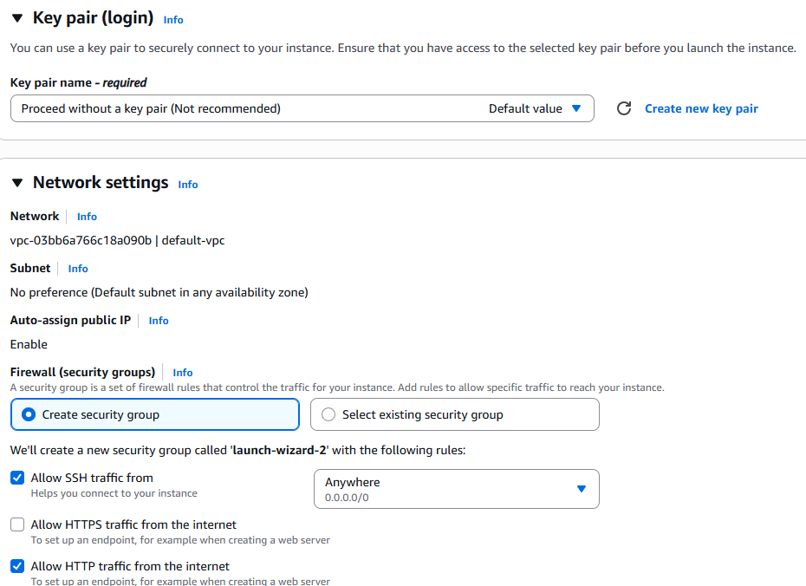

* **Install and start Apache 2 Web Server**

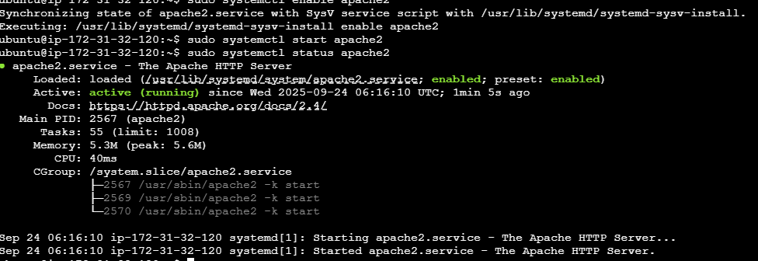

* **Create & Attach a 5 GB EBS Volume**

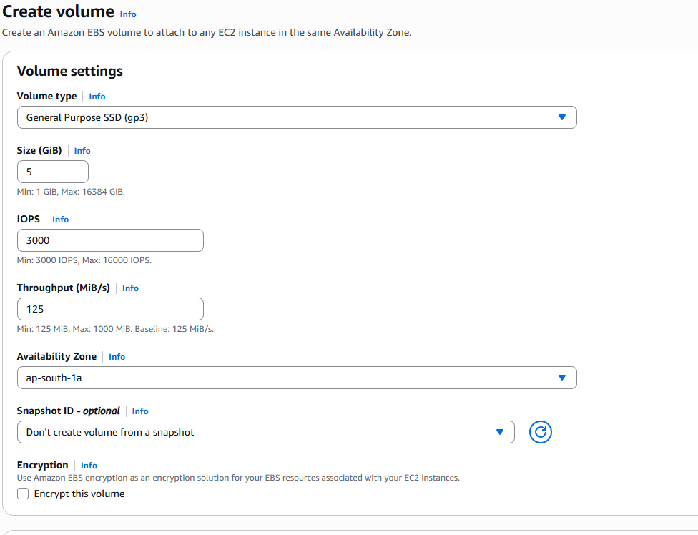

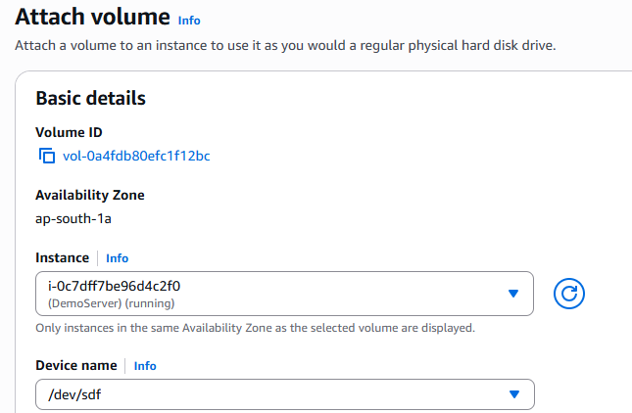

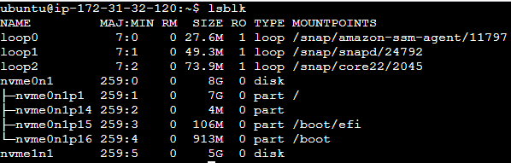

* **Mount EBS Volume**

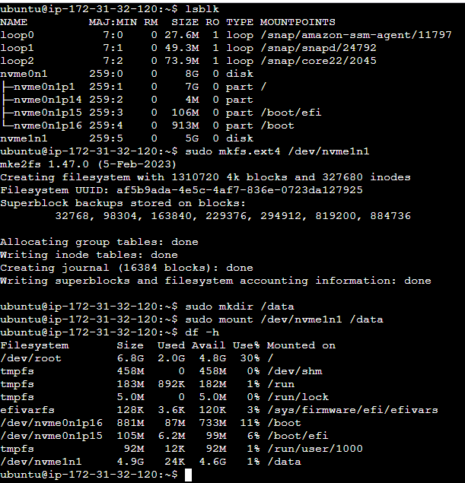

* **Create Snapshot**

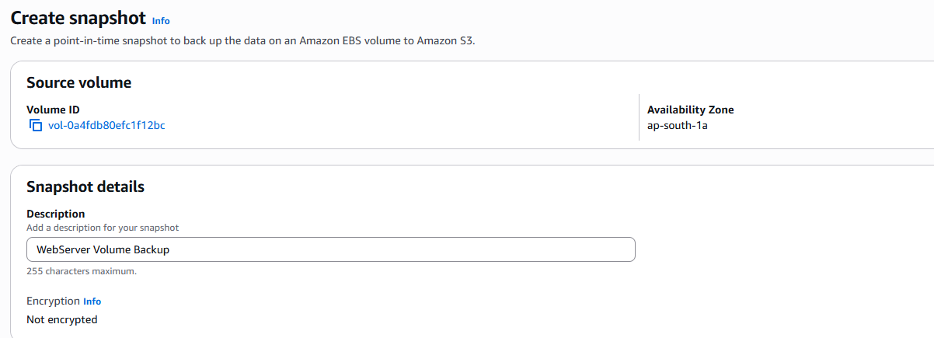

* **Create New EBS Volume from Snapshot**

